**EXPERIMENT NO.:06**

**Aim:** Scheduling and tracking of the project

**Date of Performance: Date of Submission:**

**Software Used: Gantt Project Theory:- Project Scheduling**

Project-task scheduling is a significant project planning activity. It comprises deciding which functions would be taken up when. To schedule the project plan, a software project manager wants to do the following:

* Identify all the functions required to complete the project.
* Break down large functions into small activities.
* Determine the dependency among various activities.
* Establish the most likely size for the time duration required to complete the activities.
* Allocate resources to activities.
* Plan the beginning and ending dates for different activities.
* Determine the critical path. A critical way is the group of activities that decide the duration of the project.

The first method in scheduling a software plan involves identifying all the functions required to complete the project. A good judgment of the intricacies of the project and the development process helps the supervisor to identify the critical role of the project effectively. Next, the large functions are broken down into a valid set of small activities which would be assigned to various engineers. The work breakdown structure formalism supports the manager to breakdown the function systematically after the project manager has broken down the purpose and constructs the work breakdown structure; he has to find the dependency among the activities. Dependency among the various activities determines the order in which the various events would be carried out. If an activity A necessary the results of another activity B, then activity A must be scheduled after activity B. In general, the function dependencies describe a partial ordering among functions, i.e., each service may precede a subset of other functions, but some functions might not have any precedence ordering describe between them (called concurrent function). The dependency among the activities is defined in the pattern of an activity network.

Once the activity network representation has been processed out, resources are allocated to every activity. Resource allocation is usually done using a Gantt chart. After resource allocation is completed, a PERT chart representation is developed. The PERT chart representation is useful for program monitoring and control. For task scheduling, the project plan needs to decompose the project functions into a set of activities. The time frame when

every activity is to be performed is to be determined. The end of every action is called a milestone. The project manager tracks the function of a project by audit the timely completion of the milestones. If he examines that the milestones start getting delayed, then he has to handle the activities carefully so that the complete deadline can still be met.

**Gantt Chart:**

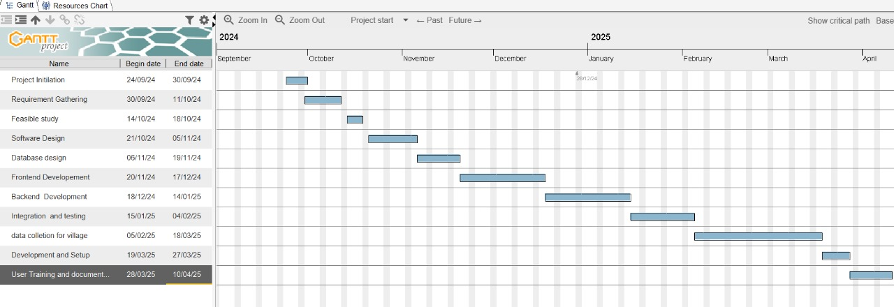

**Conclusion:**

Thus, we have scheduled and tracked our project using Gantt chart.

**Sign and Remark:**

|  |  |  |  |  |
| --- | --- | --- | --- | --- |
| **R1** | **R2** | **R3** | **Total Marks** | **Signature** |
| **(5)** | **(5)** | **(5)** | **(15)** |  |
|  |  |  |  |